**Training data**

Data collected from n=9 mice. Inflammation-induced spontaneous activity (d1 post CFA) was determined using lidocaine. V2 has been trained with 417 ‘activity’ segments and 733 ‘no activity’ segments.

**Imaging parameters and data processing:**

Nikon confocal microscope

10x objective

488nM Laser power 5-8%

Gain, 90-100

Offset 0

Pinhole – fully open

Timelapse @ 3.65Hz

512x256 pixels

Time lapse.nd2 files were loaded into Image J, **scaled to 8bit** and saved into .tiff format

Suite2p was used for timelapse registration, ROI identification and signal extraction ([suite2p](https://github.com/MouseLand/suite2p))

Suite2p Settings:

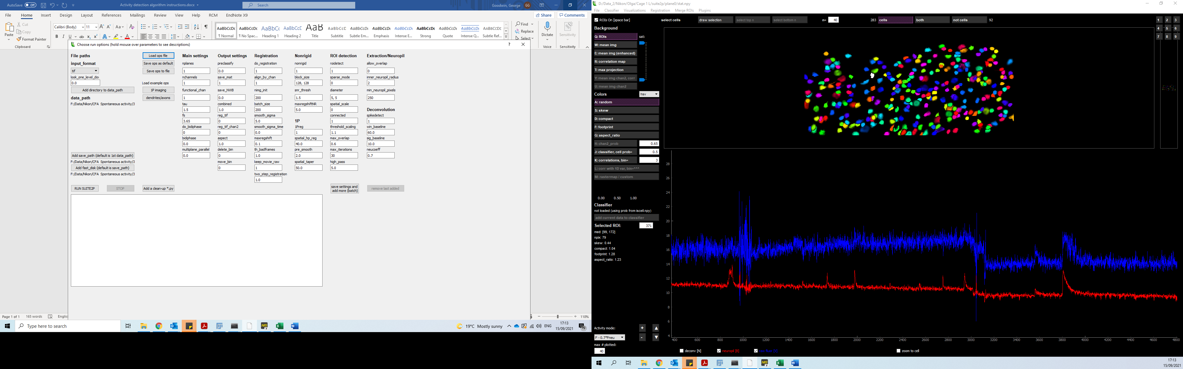

Note that the background subtracted signal data (0.4npil corrected) was used for training (not the delta f/f)

**Installing algorithm:**

Install an [Anaconda](https://www.anaconda.com/download/) distribution of Python -- Choose **Python 3.x** and your operating system

1. Clone the repo from: <https://github.com/sonialouise/ts_class> . The easiest way to do this is to download Githib desktop <https://desktop.github.com/>,
2. once downloaded, choose option “clone repository” then choose option URL and enter: <https://github.com/kclgeorge/Spont_Activity_v2> . if you are having trouble, please check [these](https://docs.github.com/en/repositories/creating-and-managing-repositories/cloning-a-repository) more comprehensive instructions.
3. Create a virtual environment to hold all libraries required to run project in clean and safe way.
   1. Open Anaconda Navigator
   2. Click on “Environments” in the Menu
   3. Choose “Create New”
   4. Choose name for your environment, e.g. “Spt_Act_algorithm”; select Python version 3.8.1 (this is important to allow for correct installation - V3.9 does not work). A new “Spt_Act_algorithm” tab should appear just below “base (root)”
   5. Click on the green “go” button next to the new “Spt_Act_algorithm” tab.
   6. Choose “Open (with) Terminal”.
   7. Change the working directory to the location of the ts_class folder

TYPE: cd “path/to/ts_class/”

NB: in windows, you may have to stay on the same drive, e.g. if you terminal is on the C drive, it will be easier to have your ts_class folder also on C.

* 1. TYPE: pip install -r requirements.txt

If you encounter an error around the installation of any of the packages, try to install them from within the anaconda environment:

1. Select the “Spt_Act_algorithm” tab.
2. Search for the missing package, changing the dropdown menu from “Installed” to “Not installed”. Select the one you want to install and click “Apply”.

**Data format:**

Data should be prepared in a .csv file, in the following format:

0 1 2 3 ...

1.2 1.3 1.4 2.0 ...

2.2 2.3 2.4 3.0 ...

header = frame number; columns = observations over time; rows = neurons

Note that the algorithm has been trained on 1049 frame segments. When testing, you must input the number of frames that the algorithm was trained +1 on i.e. 1050 frames must be entered into your .csv file

You can trial the algorithm using the test_set.csv file in path/to/github/clone/ts_class/data/test_set.csv

**Running the algorithms:**

1. Open anaconda Navigator.
2. Click on the green “go” button next to the new “Spt_Act_algorithm” tab.
3. Choose “Open with Terminal”.
4. Change the working directory to the location of the ts_class folder

TYPE: cd “path/to/ts_class/”

1. Type: python -m activity_classifier.main “path/to/data.csv” 1049